# User Maual

Creating new account and logging in. 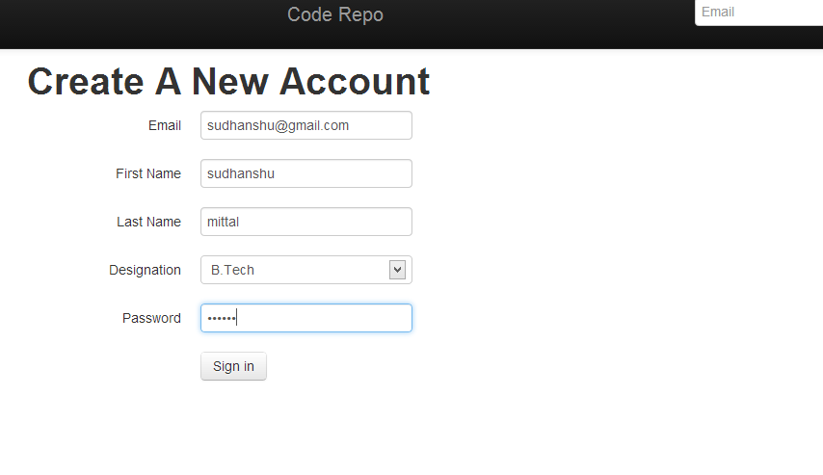

Menu bar – profile takes you to your projects. Sign out ends user session. 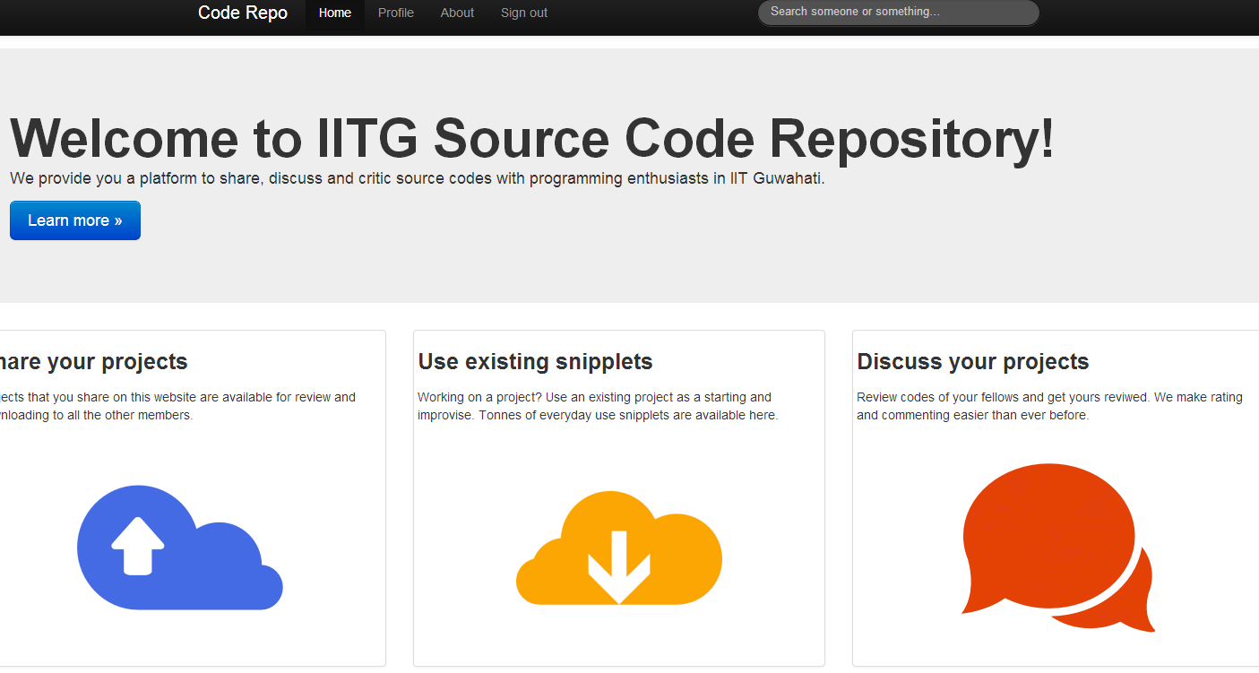

About page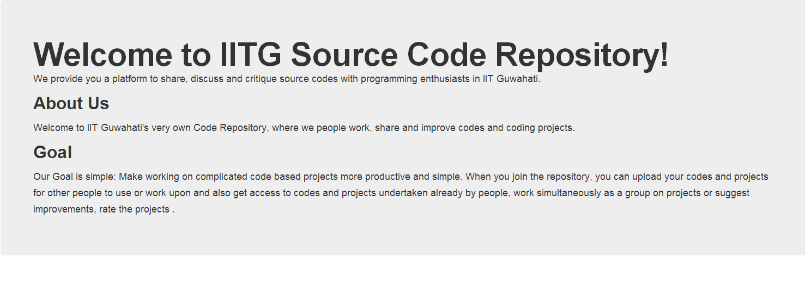

Profile page of a user. Diaplays current projects, and user info. One can create new projects using add project button.

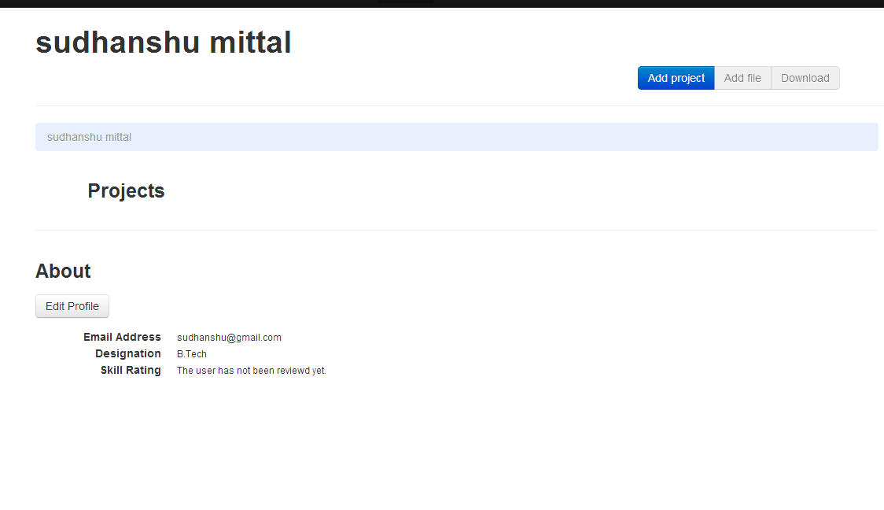Create project modal: The user inputs project info and tags to identify his project. 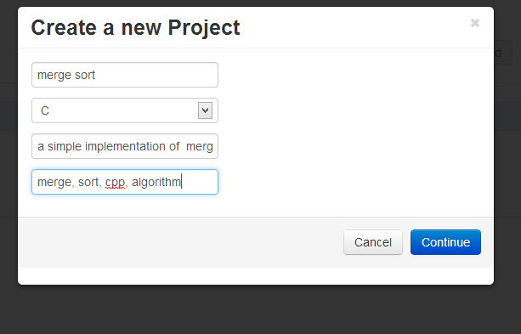Inside an project one can add files .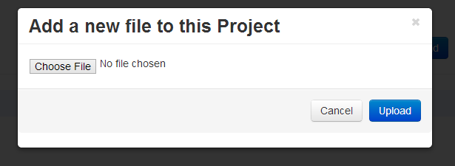

Users can comment on each others projects and discuss flaws and inprovisations.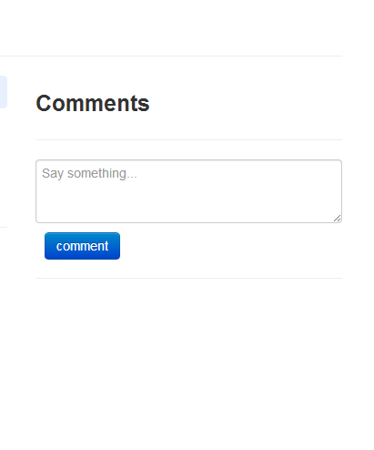

Contents of a file are generated with syntax highlighting.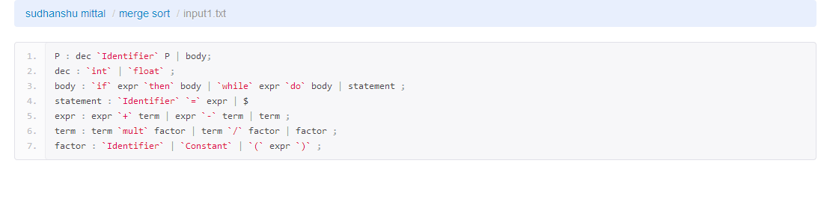

The search bar allowes users to seach from projects based on the project name, submitter name, description, language and tags.

C:\Users\Shrinivas\Desktop\ajhgsdjjakd\9.PNG

Projects that match a search are displayed .

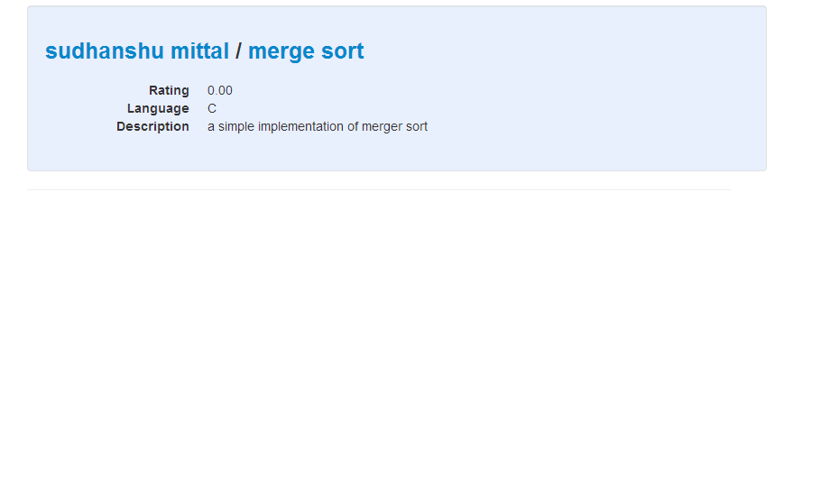

Users can rate a project based on the quality of implemetation. Of course a user can rate a project only once and he/she is not allowed to rate his own projects :P 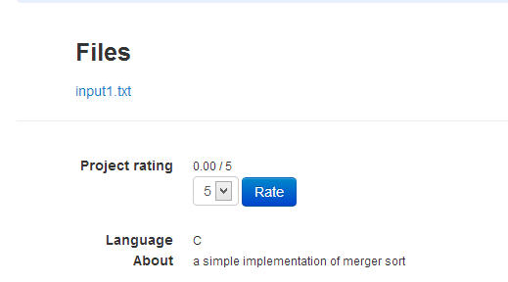

The ratings of ones projects are used to cummulatively determine his skill level.